**Introduction to HTML**

**Handout-1**

1. Design a simple Web Page to display your Name, your USN and your College Name.

Code:

Input:

Output:

1. Design a simple Web Page to display headings using h1 to h6 heading elements.

Code:

Input:

Output:

1. [Write a program to create a webpage to print your city name in red color.](https://tutorialsclass.com/exercise/create-a-webpage-to-print-your-city-name-in-red-color/)

Code:

Input:

Output:

1. [Write a program to print a paragraph with different font and color.](https://tutorialsclass.com/exercise/program-to-print-a-paragraph-with-font-and-color/)

Code:

Input:

Output:

1. [Write a program to create a webpage to print values 1 to 5](https://tutorialsclass.com/exercise/create-a-webpage-to-print-values-1-to-5/)

Code:

Input:

Output:

**Handout-2**

1. [Program to see difference between paragraphs & normal text with line break](https://tutorialsclass.com/exercise/html-paragraphs-vs-text-line-break/)

Code:

Input:

Output:

1. Write a code for basic HTML webpage with a heading and a paragraph.

Code:

Input:

Output:

1. Write a code for basic HTML webpage to dress your text by making words **bold,**or *italic*, or underlined.

Code:

Input:

Output:

1. Write a program to print H2O. The 2 in H2O should be subscripted.

Code:

Input:

Output:

**Handout-2**

1. Design a Web page to Create and display a table as shown below using colspan and rowspan Attributes

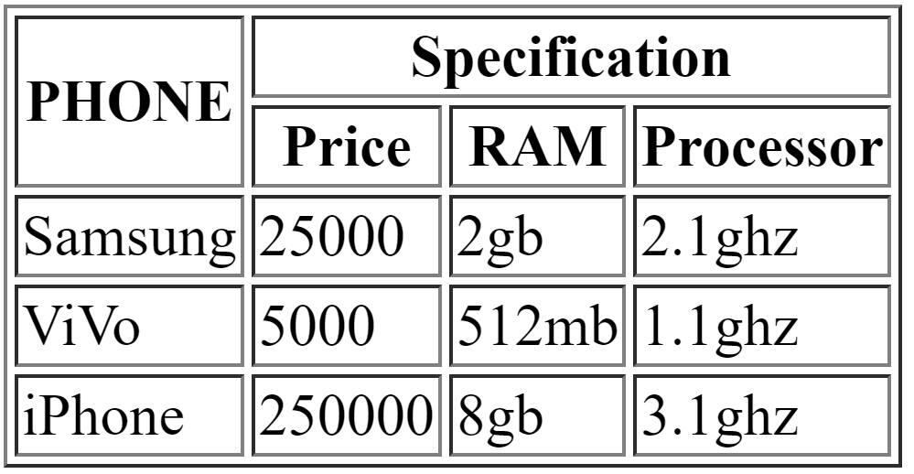

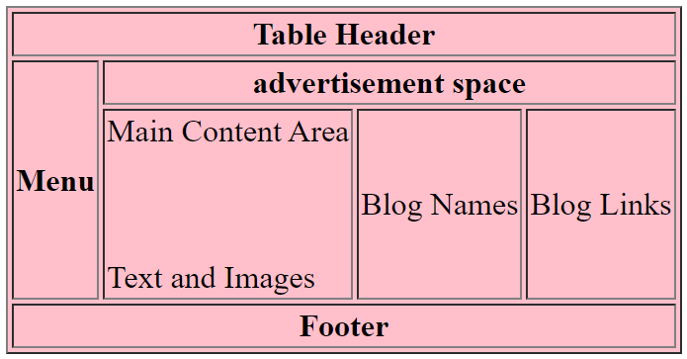

**Handout-3**

1. **Design a Web we page to embed some other web page using iframe. And also use I frame as a target frame for other site.**

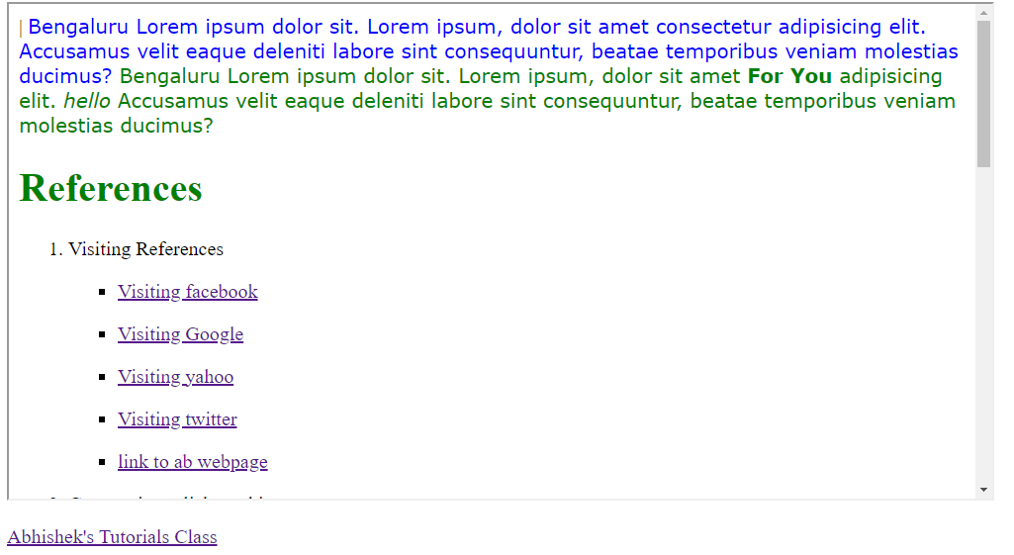

1. **Design a sign-up form using html form elements as given in the below sample:**

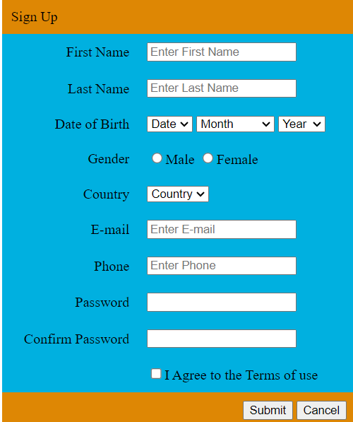

1. **Design a Registration Form using HTML5 which has textfields, textarea, checkbox, radio button, submit button, reset button, drop down box, image etc.,**

**Validate this form i.e you have to check before submitting the form whether**

1. **many field of the form is empty?**
2. **e¬mail address is a valid e¬mail address or not**
3. **password field should auto focused**

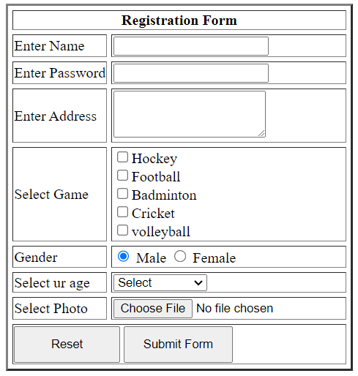

**Sample Registration form**